Blended intensive programs
Institutional Agreement/ Commitment of the parties

This statement is to confirm that the undersigning Institutions are willing to be partners within the Erasmus+ funded Blended Intensive Programme (BIP) entitled:

AI for All: Interdisciplinary Perspectives for Inclusive Futures
which consists of a virtual component on 09/09/2026 -11/09/2026 and a physical one lasting from 21/09/2026 to 25/09/2026.
All three institutions undertake to apply all the principles of the Erasmus Charter for Higher Education and to Blended Intensive Programme short mobility rules.
This project is funded through the budget of Babeș-Bolyai University, co-organizer of the Blended Intensive Program. Upon completion of the program, participants will be awarded 3 ECTS credits by the University of Rijeka.
The program will be organized by the University of Rijeka and will take place in Rijeka.
For the 2025/26 academic year, the BIP participants will meet at University of Rijeka, Faculty of Informatics and Digital Technologies – from 21/09/2026 to 25/09/2026.
……………. University will participate with a number of ……….. students and ………. academic staff.
Commitment of the parties
Sending Institution:  Name of the signatory:  Position: | Host Institution: University of Rijeka  Name of the signatory:  Position:
Signature:  Date: | Signature:  Date:
Co-organizing and Funding Institution:
Babeș- Bolyai University
Name of the signatory: Prof. Dr. Daniel David
Position: Rector

Signature:

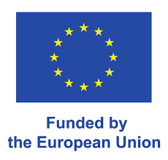
Date:

